Implement a basic CNN using PyTorch or TensorFlow

import torch
import torch.nn as nn
import torch.optim as optim
import torchvision
import torchvision.transforms as transforms

# 1. Prepare the Data
transform = transforms.Compose(
[transforms.ToTensor(),
transforms.Normalize((0.5, 0.5, 0.5), (0.5, 0.5, 0.5))])

trainset = torchvision.datasets.CIFAR10(root='./data', train=True,
download=True, transform=transform)
trainloader = torch.utils.data.DataLoader(trainset, batch_size=4,
shuffle=True, num_workers=2)

testset = torchvision.datasets.CIFAR10(root='./data', train=False,
download=True, transform=transform)
testloader = torch.utils.data.DataLoader(testset, batch_size=4,
shuffle=False, num_workers=2)

classes = ('plane', 'car', 'bird', 'cat', 'deer',
'dog', 'frog', 'horse', 'ship', 'truck')

# 2. Define the CNN Architecture
class Net(nn.Module):
def __init__(self):
super(Net, self).__init__()
self.conv1 = nn.Conv2d(3, 6, 5) # Input channels, Output channels, Kernel size
self.pool = nn.MaxPool2d(2, 2) # Kernel size, Stride
self.conv2 = nn.Conv2d(6, 16, 5)
self.fc1 = nn.Linear(16 * 5 * 5, 120) # Input features, Output features
self.fc2 = nn.Linear(120, 84)
self.fc3 = nn.Linear(84, 10) # 10 output classes

def forward(self, x):
x = self.pool(torch.relu(self.conv1(x)))
x = self.pool(torch.relu(self.conv2(x)))
x = x.view(-1, 16 * 5 * 5) # Flatten the output for fully connected layers
x = torch.relu(self.fc1(x))
x = torch.relu(self.fc2(x))
x = self.fc3(x)
return x

net = Net()

# 3. Define Loss Function and Optimizer
criterion = nn.CrossEntropyLoss()
optimizer = optim.SGD(net.parameters(), lr=0.001, momentum=0.9)

# 4. Train the Model
for epoch in range(2): # Loop over the dataset multiple times
running_loss = 0.0
for i, data in enumerate(trainloader, 0):
inputs, labels = data

optimizer.zero_grad() # Zero the parameter gradients

outputs = net(inputs) # Forward pass
loss = criterion(outputs, labels) # Calculate loss
loss.backward() # Backward pass
optimizer.step() # Optimize

running_loss += loss.item()
if i % 2000 == 1999: # Print every 2000 mini-batches
print(f'[{epoch + 1}, {i + 1:5d}] loss: {running_loss / 2000:.3f}')
running_loss = 0.0

print('Finished Training')

# 5. Evaluate the Model
correct = 0
total = 0
with torch.no_grad(): # Disable gradient calculation for evaluation
for data in testloader:
images, labels = data
outputs = net(images)
_, predicted = torch.max(outputs.data, 1)
total += labels.size(0)
correct += (predicted == labels).sum().item()

print(f'Accuracy of the network on the 10000 test images: {100 * correct / total:.2f}%')

Accuracy of the network on the 10000 test images: 54.07%

Experiment with number of filters and kernel sizes
import tensorflow as tf
from tensorflow.keras import layers, models
from tensorflow.keras.datasets import mnist
from tensorflow.keras.utils import to_categorical

# 1. Load and Preprocess Data
(x_train, y_train), (x_test, y_test) = mnist.load_data()
x_train = x_train.reshape(-1, 28, 28, 1).astype('float32') / 255
x_test = x_test.reshape(-1, 28, 28, 1).astype('float32') / 255
y_train = to_categorical(y_train, 10)
y_test = to_categorical(y_test, 10)

# 2. Define CNN Architecture
model = models.Sequential([
layers.Conv2D(16, (3, 3), padding='same', activation='relu', input_shape=(28, 28, 1)),
layers.MaxPooling2D((2, 2)),
layers.Conv2D(32, (3, 3), padding='same', activation='relu'),
layers.MaxPooling2D((2, 2)),
layers.Flatten(),
layers.Dense(128, activation='relu'),
layers.Dense(10, activation='softmax')
])

# 3. Compile and Train
model.compile(optimizer='adam', loss='categorical_crossentropy', metrics=['accuracy'])
model.fit(x_train, y_train, epochs=3, batch_size=64, validation_split=0.1)

# 4. Evaluate
test_loss, test_acc = model.evaluate(x_test, y_test)
print(f"Test Accuracy: {test_acc * 100:.2f}%")

Test Accuracy: 98.57%

Visualize learned filters from early layers
import torch
import torch.nn as nn
import torch.nn.functional as F
import torch.optim as optim
from torchvision import datasets, transforms
from torch.utils.data import DataLoader
import matplotlib.pyplot as plt

# 1. Load MNIST dataset
transform = transforms.Compose([transforms.ToTensor()])
train_data = datasets.MNIST(root='.', train=True, transform=transform, download=True)
test_data = datasets.MNIST(root='.', train=False, transform=transform)

train_loader = DataLoader(train_data, batch_size=64, shuffle=True)
test_loader = DataLoader(test_data, batch_size=64)

# 2. Define a simple CNN
class SimpleCNN(nn.Module):
def __init__(self):
super(SimpleCNN, self).__init__()
self.conv1 = nn.Conv2d(1, 8, kernel_size=3, padding=1) # output: 8x28x28
self.pool = nn.MaxPool2d(2, 2) # output: 8x14x14
self.conv2 = nn.Conv2d(8, 16, kernel_size=3, padding=1) # output: 16x14x14
self.fc1 = nn.Linear(16 * 7 * 7, 64)
self.fc2 = nn.Linear(64, 10)

def forward(self, x):
x = self.pool(F.relu(self.conv1(x))) # conv1 + relu + pool
x = self.pool(F.relu(self.conv2(x))) # conv2 + relu + pool
x = x.view(-1, 16 * 7 * 7) # flatten
x = F.relu(self.fc1(x))
x = self.fc2(x)
return x

model = SimpleCNN()

# 3. Training the model
criterion = nn.CrossEntropyLoss()
optimizer = optim.Adam(model.parameters(), lr=0.001)

print("Training model...")
for epoch in range(3):
running_loss = 0.0
for images, labels in train_loader:
optimizer.zero_grad()
outputs = model(images)
loss = criterion(outputs, labels)
loss.backward()
optimizer.step()
running_loss += loss.item()
print(f"Epoch {epoch+1} loss: {running_loss:.4f}")

print("Training complete.\n")

# 4. Visualize learned filters from the first layer
def visualize_filters(layer):
filters = layer.weight.data.clone()
filters = (filters - filters.min()) / (filters.max() - filters.min()) # normalize

num_filters = filters.shape[0]
fig, axs = plt.subplots(1, num_filters, figsize=(15, 5))
for i in range(num_filters):
axs[i].imshow(filters[i, 0, :, :], cmap='gray')
axs[i].axis('off')
axs[i].set_title(f"Filter {i+1}")
plt.suptitle("Learned Filters from First Conv Layer")
plt.tight_layout()
plt.show()

visualize_filters(model.conv1)

# 5. Visualize feature maps for a test image
def visualize_feature_maps(model, image):
model.eval()
with torch.no_grad():
x = model.conv1(image) # get feature maps from conv1
x = (x - x.min()) / (x.max() - x.min()) # normalize

num_maps = x.shape[1]
fig, axs = plt.subplots(1, num_maps, figsize=(15, 5))
for i in range(num_maps):
axs[i].imshow(x[0, i].cpu(), cmap='viridis')
axs[i].axis('off')
axs[i].set_title(f"Map {i+1}")
plt.suptitle("Feature Maps from First Conv Layer")
plt.tight_layout()
plt.show()

# Select a test image
image, label = next(iter(test_loader))
sample_image = image[0].unsqueeze(0) # (1, 1, 28, 28)

# Visualize the feature maps
visualize_feature_maps(model, sample_image)

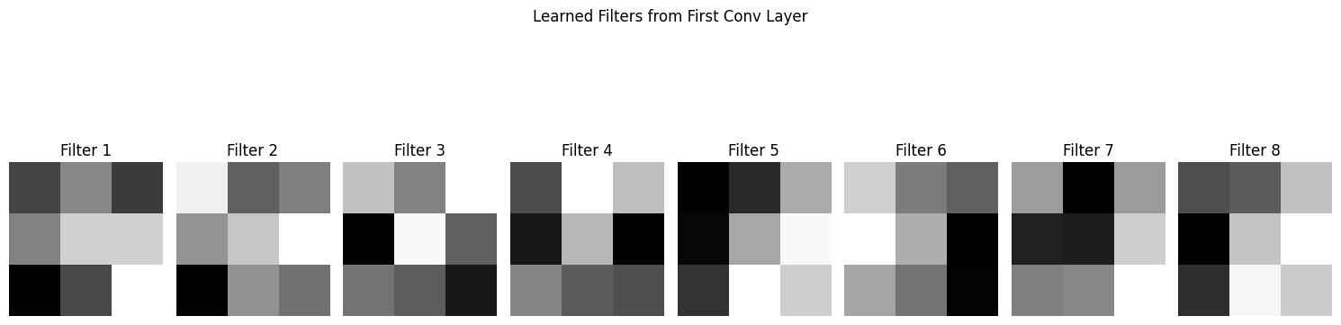
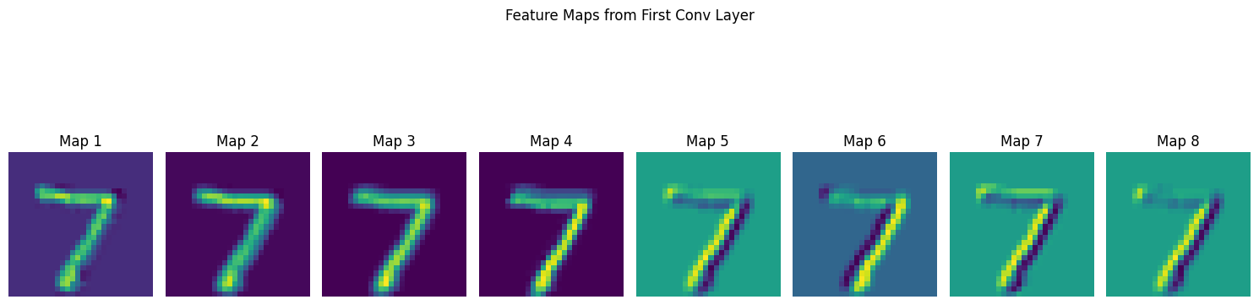

Insert pooling layers after convolution layers
import torch
import torch.nn as nn
import torch.nn.functional as F
import torch.optim as optim
from torchvision import datasets, transforms
from torch.utils.data import DataLoader
import matplotlib.pyplot as plt

# 1. Load MNIST dataset
transform = transforms.Compose([transforms.ToTensor()])
train_data = datasets.MNIST(root='.', train=True, transform=transform, download=True)
test_data = datasets.MNIST(root='.', train=False, transform=transform)

train_loader = DataLoader(train_data, batch_size=64, shuffle=True)
test_loader = DataLoader(test_data, batch_size=64)

# 2. Define CNN with pooling after conv layers
class SimpleCNN(nn.Module):
def __init__(self):
super(SimpleCNN, self).__init__()
self.conv1 = nn.Conv2d(1, 8, kernel_size=3, padding=1) # → 8x28x28
self.conv2 = nn.Conv2d(8, 16, kernel_size=3, padding=1) # → 16x14x14
self.pool = nn.MaxPool2d(2, 2) # halves each dimension
self.fc1 = nn.Linear(16 * 7 * 7, 64)
self.fc2 = nn.Linear(64, 10)

def forward(self, x):
x = F.relu(self.conv1(x)) # conv1 + ReLU
x = self.pool(x) # pool1 → 8x14x14
x = F.relu(self.conv2(x)) # conv2 + ReLU
x = self.pool(x) # pool2 → 16x7x7
x = x.view(-1, 16 * 7 * 7) # flatten
x = F.relu(self.fc1(x)) # dense layer
x = self.fc2(x) # output layer
return x

model = SimpleCNN()

# 3. Training setup
criterion = nn.CrossEntropyLoss()
optimizer = optim.Adam(model.parameters(), lr=0.001)

# 4. Training loop
print("Training model...")
for epoch in range(3):
running_loss = 0.0
for images, labels in train_loader:
optimizer.zero_grad()
outputs = model(images)
loss = criterion(outputs, labels)
loss.backward()
optimizer.step()
running_loss += loss.item()
print(f"Epoch {epoch+1} loss: {running_loss:.4f}")

print("Training complete.\n")

# 5. Visualize learned filters from conv1
def visualize_filters(layer):
filters = layer.weight.data.clone()
filters = (filters - filters.min()) / (filters.max() - filters.min())

num_filters = filters.shape[0]
fig, axs = plt.subplots(1, num_filters, figsize=(15, 5))
for i in range(num_filters):
axs[i].imshow(filters[i, 0, :, :], cmap='gray')
axs[i].axis('off')
axs[i].set_title(f"Filter {i+1}")
plt.suptitle("Learned Filters from conv1")
plt.tight_layout()
plt.show()

visualize_filters(model.conv1)

# 6. Visualize feature maps after conv1
def visualize_feature_maps(model, image):
model.eval()
with torch.no_grad():
x = F.relu(model.conv1(image))
x = model.pool(x) # include pooling step
x = (x - x.min()) / (x.max() - x.min())

num_maps = x.shape[1]
fig, axs = plt.subplots(1, num_maps, figsize=(15, 5))
for i in range(num_maps):
axs[i].imshow(x[0, i].cpu(), cmap='viridis')
axs[i].axis('off')
axs[i].set_title(f"Map {i+1}")
plt.suptitle("Feature Maps After conv1 + Pooling")
plt.tight_layout()
plt.show()

# 7. Pick a test image and visualize
image, label = next(iter(test_loader))
sample_image = image[0].unsqueeze(0) # shape: (1, 1, 28, 28)
visualize_feature_maps(model, sample_image)

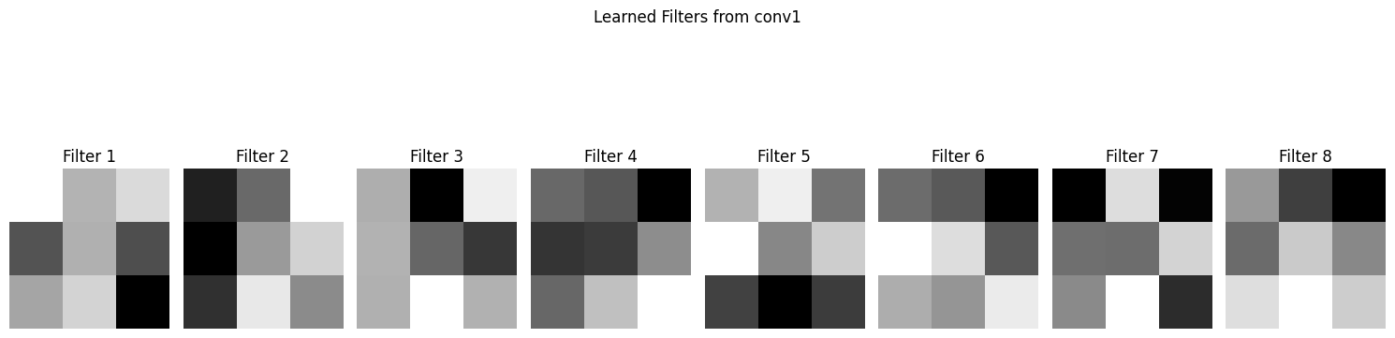
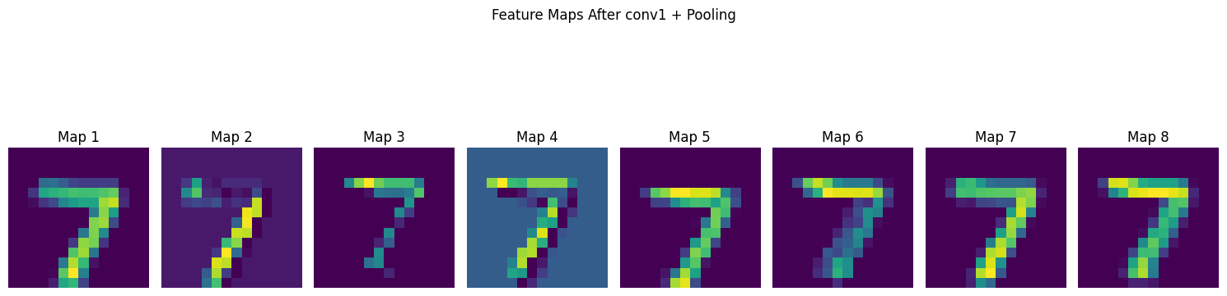

Visualize pooling effects on images

import torch
import torchvision
import torchvision.transforms as transforms
import matplotlib.pyplot as plt
import torch.nn.functional as F

# 1. Load a sample MNIST image
transform = transforms.Compose([transforms.ToTensor()])
test_data = torchvision.datasets.MNIST(root='.', train=False, transform=transform, download=True)
sample_image, label = test_data[0] # get 1 image
print(f"Label: {label}")

# Reshape to match CNN input: (1, 1, 28, 28)
image = sample_image.unsqueeze(0)

# 2. Apply pooling
max_pooled = F.max_pool2d(image, kernel_size=2, stride=2)
avg_pooled = F.avg_pool2d(image, kernel_size=2, stride=2)

# 3. Convert to numpy for visualization
original = image.squeeze().numpy()
max_pool = max_pooled.squeeze().numpy()
avg_pool = avg_pooled.squeeze().numpy()

# 4. Plot all three
fig, axs = plt.subplots(1, 3, figsize=(12, 4))

axs[0].imshow(original, cmap='gray')
axs[0].set_title("Original (28x28)")
axs[0].axis('off')

axs[1].imshow(max_pool, cmap='gray')
axs[1].set_title("Max Pooled (14x14)")
axs[1].axis('off')

axs[2].imshow(avg_pool, cmap='gray')
axs[2].set_title("Avg Pooled (14x14)")
axs[2].axis('off')

plt.suptitle("Effect of Pooling on MNIST Image", fontsize=14)
plt.tight_layout()
plt.show()

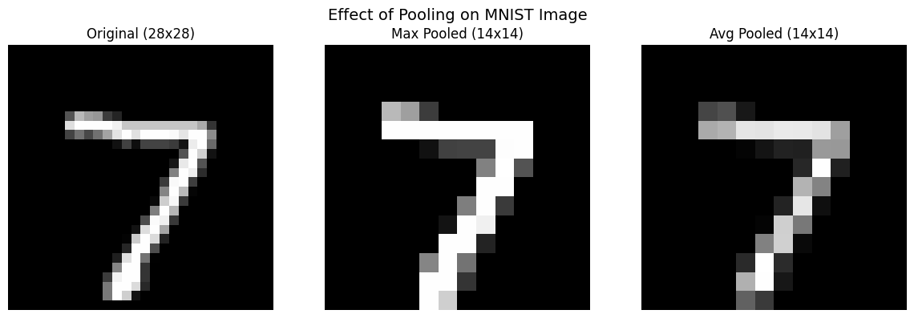

Compare CNNs with and without pooling

import torch
import torch.nn as nn
import torch.nn.functional as F
import torch.optim as optim
from torchvision import datasets, transforms
from torch.utils.data import DataLoader

# Load MNIST
transform = transforms.ToTensor()
train_data = datasets.MNIST(root='.', train=True, transform=transform, download=True)
test_data = datasets.MNIST(root='.', train=False, transform=transform)

train_loader = DataLoader(train_data, batch_size=64, shuffle=True)
test_loader = DataLoader(test_data, batch_size=64)

# Model A: With pooling
class CNNWithPooling(nn.Module):
def __init__(self):
super(CNNWithPooling, self).__init__()
self.conv1 = nn.Conv2d(1, 16, 3, padding=1) # 28x28
self.pool = nn.MaxPool2d(2, 2) # 14x14
self.conv2 = nn.Conv2d(16, 32, 3, padding=1) # 14x14 → 7x7
self.fc1 = nn.Linear(32 * 7 * 7, 128)
self.fc2 = nn.Linear(128, 10)

def forward(self, x):
x = self.pool(F.relu(self.conv1(x)))
x = self.pool(F.relu(self.conv2(x)))
x = x.view(-1, 32 * 7 * 7)
x = F.relu(self.fc1(x))
return self.fc2(x)

# Model B: Without pooling
class CNNWithoutPooling(nn.Module):
def __init__(self):
super(CNNWithoutPooling, self).__init__()
self.conv1 = nn.Conv2d(1, 16, 3, padding=1) # 28x28
self.conv2 = nn.Conv2d(16, 32, 3, padding=1) # 28x28
self.fc1 = nn.Linear(32 * 28 * 28, 128)
self.fc2 = nn.Linear(128, 10)

def forward(self, x):
x = F.relu(self.conv1(x)) # no pooling
x = F.relu(self.conv2(x))
x = x.view(-1, 32 * 28 * 28)
x = F.relu(self.fc1(x))
return self.fc2(x)

# Train function
def train(model, epochs=3):
optimizer = optim.Adam(model.parameters(), lr=0.001)
criterion = nn.CrossEntropyLoss()

model.train()
for epoch in range(epochs):
running_loss = 0
for images, labels in train_loader:
optimizer.zero_grad()
outputs = model(images)
loss = criterion(outputs, labels)
loss.backward()
optimizer.step()
running_loss += loss.item()
print(f"Epoch {epoch+1} Loss: {running_loss:.2f}")

# Test function
def test(model):
model.eval()
correct, total = 0, 0
with torch.no_grad():
for images, labels in test_loader:
outputs = model(images)
_, predicted = torch.max(outputs, 1)
total += labels.size(0)
correct += (predicted == labels).sum().item()
return 100 * correct / total

# Instantiate and train both models
print("\n🔷 Training Model A: With Pooling")
model_a = CNNWithPooling()
train(model_a)
acc_a = test(model_a)
print(f"✅ Model A Accuracy: {acc_a:.2f}%\n")

print("🔶 Training Model B: Without Pooling")
model_b = CNNWithoutPooling()
train(model_b)
acc_b = test(model_b)
print(f"✅ Model B Accuracy: {acc_b:.2f}%")

Training Model A: With Pooling
Epoch 1 Loss: 208.24
Epoch 2 Loss: 57.04
Epoch 3 Loss: 39.32
Model A Accuracy: 98.91%
Training Model B: Without Pooling Epoch
1 Loss: 150.13 Epoch 2 Loss: 42.00
Epoch 3 Loss: 23.66 ✅ Model B Accuracy: 98.41%

Train an RNN on time series or text data
import numpy as np
import torch
import torch.nn as nn
import matplotlib.pyplot as plt
# Create a sine wave
x = np.linspace(0, 100, 1000)
y = np.sin(x)

# Prepare sequences
def create_sequences(data, seq_length):
xs, ys = [], []
for i in range(len(data) - seq_length):
xs.append(data[i:i+seq_length])
ys.append(data[i+seq_length])
return np.array(xs), np.array(ys)

seq_length = 50
X, Y = create_sequences(y, seq_length)

# Convert to PyTorch tensors
X = torch.tensor(X).float().unsqueeze(-1) # shape: (samples, seq_len, 1)
Y = torch.tensor(Y).float().unsqueeze(-1) # shape: (samples, 1)
class RNNPredictor(nn.Module):
def __init__(self, input_size=1, hidden_size=32, num_layers=1):
super(RNNPredictor, self).__init__()
self.rnn = nn.RNN(input_size, hidden_size, num_layers, batch_first=True)
self.fc = nn.Linear(hidden_size, 1)

def forward(self, x):
out, _ = self.rnn(x)
out = self.fc(out[:, -1, :]) # take only last output
return out

model = RNNPredictor()
criterion = nn.MSELoss()
optimizer = torch.optim.Adam(model.parameters(), lr=0.01)

epochs = 100
for epoch in range(epochs):
output = model(X)
loss = criterion(output, Y)
optimizer.zero_grad()
loss.backward()
optimizer.step()

if (epoch+1) % 10 == 0:
print(f"Epoch {epoch+1}/{epochs}, Loss: {loss.item():.4f}")
with torch.no_grad():
preds = model(X).squeeze().numpy()

plt.figure(figsize=(12, 4))
plt.plot(Y.numpy().flatten(), label='Actual')
plt.plot(preds, label='Predicted')
plt.legend()
plt.title("RNN Time Series Prediction (Sine Wave)")
plt.show()

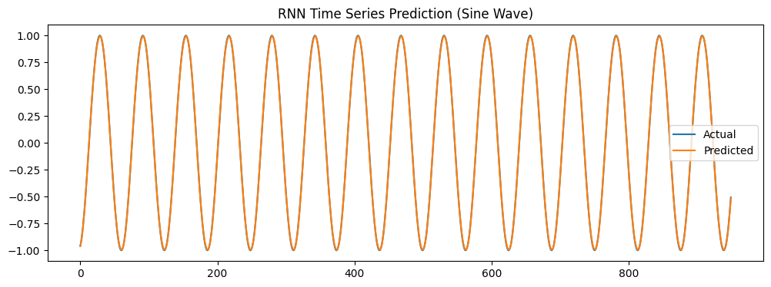
Visualize memory cell activations over time
import torch
import torch.nn as nn
import matplotlib.pyplot as plt

# Sample input: batch size=1, sequence length=10, input_size=5
seq_len = 10
input_size = 5
hidden_size = 8 # number of LSTM cells

# Create random input sequence
x = torch.randn(1, seq_len, input_size)

# Define LSTM layer
lstm = nn.LSTM(input_size=input_size, hidden_size=hidden_size, batch_first=True)

# Initialize hidden state and cell state to zeros
h0 = torch.zeros(1, 1, hidden_size) # (num_layers, batch, hidden_size)
c0 = torch.zeros(1, 1, hidden_size)

# To store cell states and hidden states for each time step
cell_states_list = []
hidden_states_list = []

# Process input sequence one step at a time to capture states
for t in range(seq_len):
xt = x[:, t, :].unsqueeze(1) # shape: (1, 1, input_size)
out, (h0, c0) = lstm(xt, (h0, c0))
hidden_states_list.append(h0.squeeze(0)) # shape: (1, hidden_size)
cell_states_list.append(c0.squeeze(0)) # shape: (1, hidden_size)

# Stack the lists of tensors into single tensors
cell_states = torch.stack(cell_states_list).squeeze(1).detach().numpy() # shape: (seq_len, hidden_size)
hidden_states = torch.stack(hidden_states_list).squeeze(1).detach().numpy() # shape: (seq_len, hidden_size)

# Plot memory cell activations over time
plt.figure(figsize=(12, 6))
for i in range(hidden_size):
plt.plot(range(seq_len), cell_states[:, i], label=f'Cell {i+1}')
plt.xlabel('Time Step')
plt.ylabel('Cell State Activation')
plt.title('LSTM Memory Cell Activations Over Time')
plt.legend(loc='upper right', bbox_to_anchor=(1.15, 1))
plt.tight_layout()
plt.show()
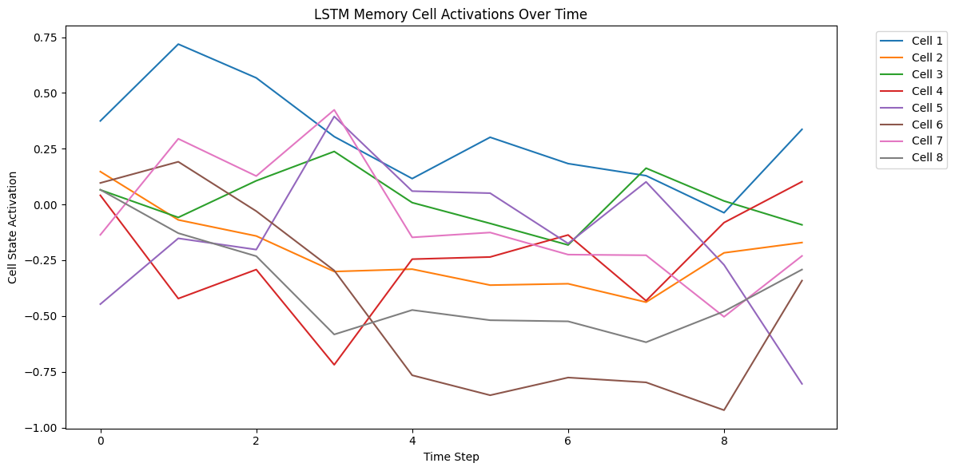
Visualize gate outputs and sequence handling
import torch
import torch.nn as nn
import matplotlib.pyplot as plt

class CustomLSTMCell(nn.Module):
def __init__(self, input_size, hidden_size):
super().__init__()
self.input_size = input_size
self.hidden_size = hidden_size

# Gates: input, forget, cell candidate, output
self.W_i = nn.Linear(input_size, hidden_size)
self.U_i = nn.Linear(hidden_size, hidden_size, bias=False)

self.W_f = nn.Linear(input_size, hidden_size)
self.U_f = nn.Linear(hidden_size, hidden_size, bias=False)

self.W_c = nn.Linear(input_size, hidden_size)
self.U_c = nn.Linear(hidden_size, hidden_size, bias=False)

self.W_o = nn.Linear(input_size, hidden_size)
self.U_o = nn.Linear(hidden_size, hidden_size, bias=False)

def forward(self, x, hx):
h_prev, c_prev = hx

i = torch.sigmoid(self.W_i(x) + self.U_i(h_prev)) # input gate
f = torch.sigmoid(self.W_f(x) + self.U_f(h_prev)) # forget gate
c_bar = torch.tanh(self.W_c(x) + self.U_c(h_prev)) # candidate cell state
c = f * c_prev + i * c_bar # new cell state
o = torch.sigmoid(self.W_o(x) + self.U_o(h_prev)) # output gate
h = o * torch.tanh(c) # new hidden state

gates = {'input_gate': i, 'forget_gate': f, 'output_gate': o, 'cell_candidate': c_bar}
return h, c, gates

class CustomLSTM(nn.Module):
def __init__(self, input_size, hidden_size):
super().__init__()
self.hidden_size = hidden_size
self.lstm_cell = CustomLSTMCell(input_size, hidden_size)

def forward(self, x):
# x shape: (batch, seq_len, input_size)
batch_size, seq_len, _ = x.size()
h = torch.zeros(batch_size, self.hidden_size)
c = torch.zeros(batch_size, self.hidden_size)

input_gates, forget_gates, output_gates, cell_candidates = [], [], [], []
outputs = []

for t in range(seq_len):
h, c, gates = self.lstm_cell(x[:, t, :], (h, c))
outputs.append(h.unsqueeze(1))
input_gates.append(gates['input_gate'].detach().numpy())
forget_gates.append(gates['forget_gate'].detach().numpy())
output_gates.append(gates['output_gate'].detach().numpy())
cell_candidates.append(gates['cell_candidate'].detach().numpy())

outputs = torch.cat(outputs, dim=1)
return outputs, input_gates, forget_gates, output_gates, cell_candidates

# Sample input: batch=1, seq_len=15, input_size=3
seq_len = 15
input_size = 3
hidden_size = 5

x = torch.randn(1, seq_len, input_size)

model = CustomLSTM(input_size, hidden_size)
outputs, i_gates, f_gates, o_gates, c_cand = model(x)

# Convert gate lists to arrays: (seq_len, hidden_size)
import numpy as np

i_gates = np.vstack(i_gates)
f_gates = np.vstack(f_gates)
o_gates = np.vstack(o_gates)
c_cand = np.vstack(c_cand)

# Plotting gate activations over time for each cell
plt.figure(figsize=(14, 8))

for idx, gate_data in enumerate([i_gates, f_gates, o_gates]):
plt.subplot(3,1,idx+1)
for cell in range(hidden_size):
plt.plot(range(seq_len), gate_data[:, cell], label=f'Cell {cell+1}')
plt.title(['Input Gate', 'Forget Gate', 'Output Gate'][idx])
plt.xlabel('Time Step')
plt.ylabel('Activation')
plt.ylim(0,1)
plt.legend(loc='upper right', bbox_to_anchor=(1.12, 1))
plt.tight_layout()

plt.show()

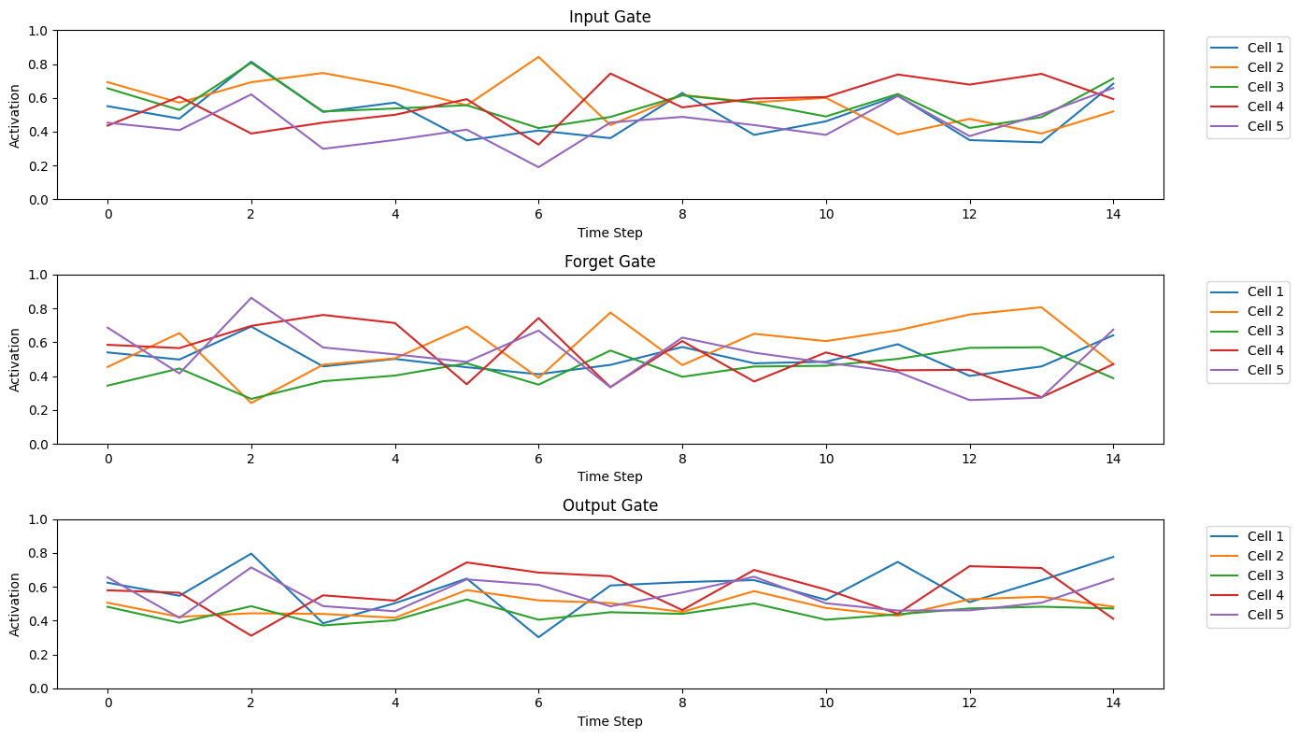
Build a vanilla autoencoder for image reconstruction

import torch
import torch.nn as nn
import torch.optim as optim
from torchvision import datasets, transforms
from torch.utils.data import DataLoader
import matplotlib.pyplot as plt

# 1. Device
device = torch.device("cuda" if torch.cuda.is_available() else "cpu")

# 2. Data: MNIST (28x28 grayscale images)
transform = transforms.ToTensor()
train_dataset = datasets.MNIST(root='./data', train=True, download=True, transform=transform)
test_dataset = datasets.MNIST(root='./data', train=False, download=True, transform=transform)

train_loader = DataLoader(train_dataset, batch_size=128, shuffle=True)
test_loader = DataLoader(test_dataset, batch_size=128, shuffle=False)

# 3. Define Vanilla Autoencoder
class Autoencoder(nn.Module):
def __init__(self):
super().__init__()
# Encoder
self.encoder = nn.Sequential(
nn.Flatten(),
nn.Linear(28*28, 128),
nn.ReLU(),
nn.Linear(128, 64),
nn.ReLU(),
nn.Linear(64, 32) # latent space
)
# Decoder
self.decoder = nn.Sequential(
nn.Linear(32, 64),
nn.ReLU(),
nn.Linear(64, 128),
nn.ReLU(),
nn.Linear(128, 28*28),
nn.Sigmoid(), # output pixel values between 0 and 1
nn.Unflatten(1, (1, 28, 28))
)

def forward(self, x):
latent = self.encoder(x)
reconstructed = self.decoder(latent)
return reconstructed

model = Autoencoder().to(device)

# 4. Loss and Optimizer
criterion = nn.BCELoss()
optimizer = optim.Adam(model.parameters(), lr=1e-3)

# 5. Training loop
epochs = 10
for epoch in range(epochs):
model.train()
total_loss = 0
for imgs, _ in train_loader:
imgs = imgs.to(device)
outputs = model(imgs)
loss = criterion(outputs, imgs)
optimizer.zero_grad()
loss.backward()
optimizer.step()
total_loss += loss.item()
print(f"Epoch [{epoch+1}/{epochs}], Loss: {total_loss/len(train_loader):.4f}")

# 6. Visualize original and reconstructed images
model.eval()
with torch.no_grad():
imgs, _ = next(iter(test_loader))
imgs = imgs.to(device)
recon = model(imgs)

imgs = imgs.cpu()
recon = recon.cpu()

fig, axes = plt.subplots(2, 8, figsize=(12,4))
for i in range(8):
axes[0, i].imshow(imgs[i].squeeze(), cmap='gray')
axes[0, i].axis('off')
axes[0, i].set_title('Original')

axes[1, i].imshow(recon[i].squeeze(), cmap='gray')
axes[1, i].axis('off')
axes[1, i].set_title('Reconstructed')

plt.tight_layout()
plt.show()

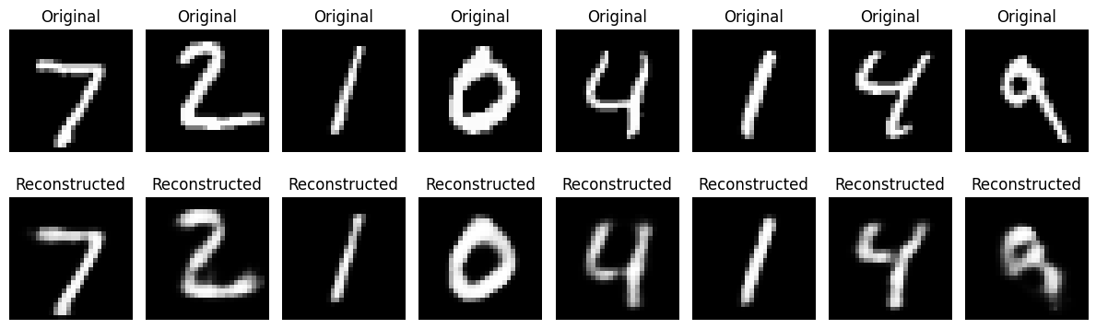

Plot generator outputs over epochs

import torch
import torch.nn as nn
import torch.optim as optim
from torchvision import datasets, transforms
from torch.utils.data import DataLoader
import matplotlib.pyplot as plt

# Device setup
device = torch.device("cuda" if torch.cuda.is_available() else "cpu")

# Hyperparameters
latent_dim = 100
lr = 0.0002
batch_size = 128
epochs = 30

# Data preparation (normalize to [-1, 1])
transform = transforms.Compose([
transforms.ToTensor(),
transforms.Normalize([0.5], [0.5])
])
train_dataset = datasets.MNIST(root='./data', train=True, download=True, transform=transform)
dataloader = DataLoader(train_dataset, batch_size=batch_size, shuffle=True)

# Generator
class Generator(nn.Module):
def __init__(self):
super().__init__()
self.net = nn.Sequential(
nn.Linear(latent_dim, 256),
nn.ReLU(True),
nn.Linear(256, 512),
nn.ReLU(True),
nn.Linear(512, 1024),
nn.ReLU(True),
nn.Linear(1024, 28 * 28),
nn.Tanh() # Output in [-1, 1]
)

def forward(self, z):
out = self.net(z)
return out.view(-1, 1, 28, 28)

# Discriminator
class Discriminator(nn.Module):
def __init__(self):
super().__init__()
self.net = nn.Sequential(
nn.Flatten(),
nn.Linear(28 * 28, 512),
nn.LeakyReLU(0.2, inplace=True),
nn.Linear(512, 256),
nn.LeakyReLU(0.2, inplace=True),
nn.Linear(256, 1),
nn.Sigmoid()
)

def forward(self, x):
return self.net(x)

# Initialize models
generator = Generator().to(device)
discriminator = Discriminator().to(device)

# Loss and optimizers
loss_fn = nn.BCELoss()
opt_G = optim.Adam(generator.parameters(), lr=lr, betas=(0.5, 0.999))
opt_D = optim.Adam(discriminator.parameters(), lr=lr, betas=(0.5, 0.999))

# Training loop
for epoch in range(epochs):
for i, (real_imgs, _) in enumerate(dataloader):
real_imgs = real_imgs.to(device)
batch_size = real_imgs.size(0)

# Ground truths
real_labels = torch.ones(batch_size, 1).to(device)
fake_labels = torch.zeros(batch_size, 1).to(device)

### Train Discriminator ###
z = torch.randn(batch_size, latent_dim).to(device)
fake_imgs = generator(z)
d_real = discriminator(real_imgs)
d_fake = discriminator(fake_imgs.detach())
d_loss = loss_fn(d_real, real_labels) + loss_fn(d_fake, fake_labels)

opt_D.zero_grad()
d_loss.backward()
opt_D.step()

### Train Generator ###
z = torch.randn(batch_size, latent_dim).to(device)
fake_imgs = generator(z)
d_pred = discriminator(fake_imgs)
g_loss = loss_fn(d_pred, real_labels) # Generator wants D to think fakes are real

opt_G.zero_grad()
g_loss.backward()
opt_G.step()

print(f"Epoch [{epoch+1}/{epochs}] | D Loss: {d_loss.item():.4f} | G Loss: {g_loss.item():.4f}")

# Visualize progress
if (epoch + 1) % 5 == 0:
generator.eval()
with torch.no_grad():
z = torch.randn(16, latent_dim).to(device)
gen_imgs = generator(z).cpu()

fig, axes = plt.subplots(1, 16, figsize=(16, 2))
for j in range(16):
axes[j].imshow(gen_imgs[j].squeeze(), cmap='gray')
axes[j].axis('off')
plt.suptitle(f'Generated Digits - Epoch {epoch+1}')
plt.show()
generator.train()

